

INTRODUCTION
The Forbes global data is a business data that tells us about the performance of some business organizations based on the industries ranging from banking, oil and etcetera.

PROBLEM STATEMENT
What is the performance of businesses based on the industry, comparing different business measures across the industries as well as the business organizations itself ?

SKILLS/CONCEPTS DEMONSTRATED
The following tools and skills were used in this project:
Excel used for data anlaysis
PowerBI used to design the visualizations and dashboard.

DATA SOURCING
It was a one table dataset gotten from the query.data.world

DATA TRANSFORMATION/CLEANING
The data was efficiently cleaned and transformed using Excel. Some of the steps are listed below:
Conversion of the data types of some variables
Removal of null values
Attempt to remove duplicates

METHODOLOGY
Generation of problem statement
Data transformation/cleaning

ANALYSIS AND VISUALIZATION
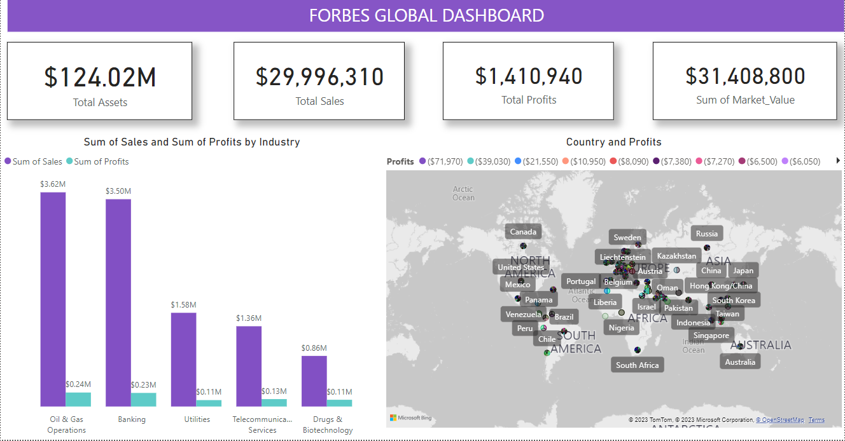

According to our dashboard, here are the following observations:

So far, there have been 5 Industry with highest sales and profit which are
Oil and Gas Operations
Banking
Utilities
Telecommunication Services
Drugs & Biotechnology
Also, the sum of Total Assets, total sales, total profits and sum of market value from the year 2008-2022 were also displayed in the dashboard

CONCLUSIONS
From the Forbes Global reports we can observed that Oil and Gas Operations had the highest sales and profit. Looking at the wide usage of oil and gas over the world. From our report, we observed that high profits was also made in the Asia continent.

ACKNOWLEDGEMENTS
Special thanks to my Instructors, Mr. Francis & Mr. Evans, for working with me to make this project a huge success.

